**NITTE MEENAKSHI INSTITUTE OF TECHNOLOGY**

**(An autonomous institution with A Grade by NAAC /UGC, Affiliated to Visvesvaraya Technological University,**

**Belgaum, Approved by UGC/AICTE/Govt. of Karnataka)**  **Yelahanka, Bengaluru-560064**

**ACADEMIC YEAR 2020-2021**



**SUBJECT: HYBRID APP DEVELOPMENT**

# SQLite Project

**Submitted To:**

Prof.Prashanth B.S

**Submitted by:**

Deshmukh Pankaj

**USN:1NT17IS0047**

**Design an admin page in which the users can be added/removed/updated in the SqliteDatabase and Registration page for the admin, admin page, login page.**

**Github link for the project :**

**SCREENSHOTS OF THE APP:-**

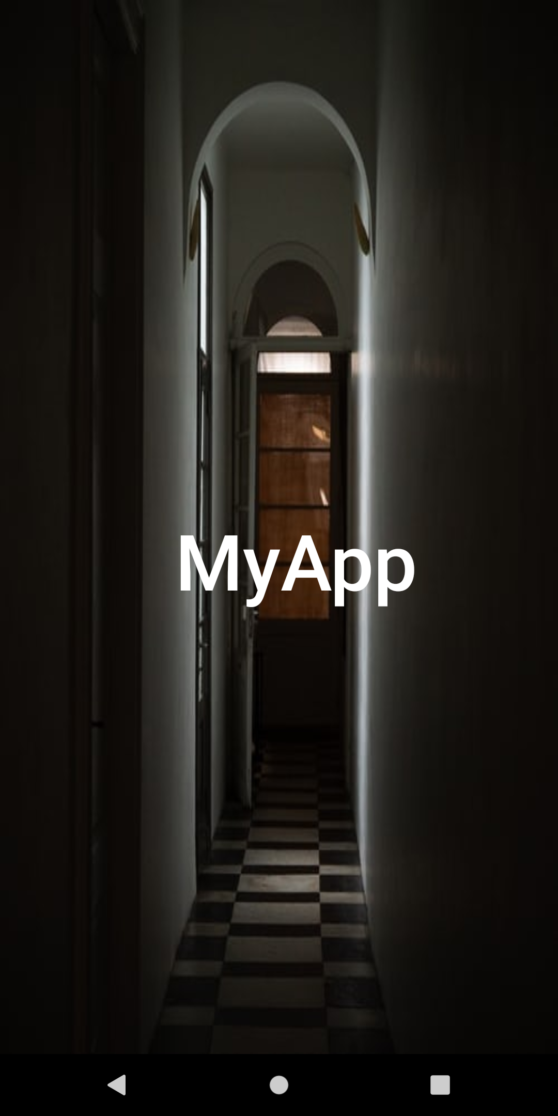

**Mainactivity.java**

|  |
| --- |
| package com.example.sqlitedemo;    import androidx.appcompat.app.AppCompatActivity;    import android.content.Intent; import android.os.Bundle; import android.os.Handler;  import android.view.WindowManager;    public class MainActivity extends AppCompatActivity { private static int SPLASH_SCREEN_TIME_OUT=1500;    @Override  protected void onCreate(Bundle savedInstanceState) { super.onCreate(savedInstanceState);  getWindow().setFlags(WindowManager.LayoutParams.FLAG_FULLSCREEN,  WindowManager.LayoutParams.FLAG_FULLSCREEN); setContentView(R.layout.activity_main); new Handler().postDelayed(new Runnable() {  @Override  public void run() {  Intent i=new Intent(MainActivity.this, MainActivity2.class);  startActivity(i); finish();  }  }, SPLASH_SCREEN_TIME_OUT);  }  } |

**activity_main.xml**

<androidx.constraintlayout.widget.ConstraintLayout xmlns:android="http://schemas.android.com/apk/res/android"  
 xmlns:app="http://schemas.android.com/apk/res-auto"  
 xmlns:tools="http://schemas.android.com/tools"  
 android:layout_width="match_parent"  
 android:layout_height="match_parent"  
 android:background="@drawable/abc1"  
 tools:context=".MainActivity">  
  
 <TextView  
 android:id="@+id/textView2"  
 android:layout_width="wrap_content"  
 android:layout_height="wrap_content"  
 android:fontFamily="sans-serif-medium"  
 android:text="MyApp"  
 android:textAppearance="@style/TextAppearance.AppCompat.Body1"  
 android:textColor="#FFFFFF"  
 android:textSize="60sp"  
 app:layout_constraintBottom_toBottomOf="parent"  
 app:layout_constraintEnd_toEndOf="parent"  
 app:layout_constraintHorizontal_bias="0.555"  
 app:layout_constraintStart_toStartOf="parent"  
 app:layout_constraintTop_toTopOf="parent"  
 app:layout_constraintVertical_bias="0.535" />  
  
</androidx.constraintlayout.widget.ConstraintLayout>

**2.WELCOME ACTIVITY**

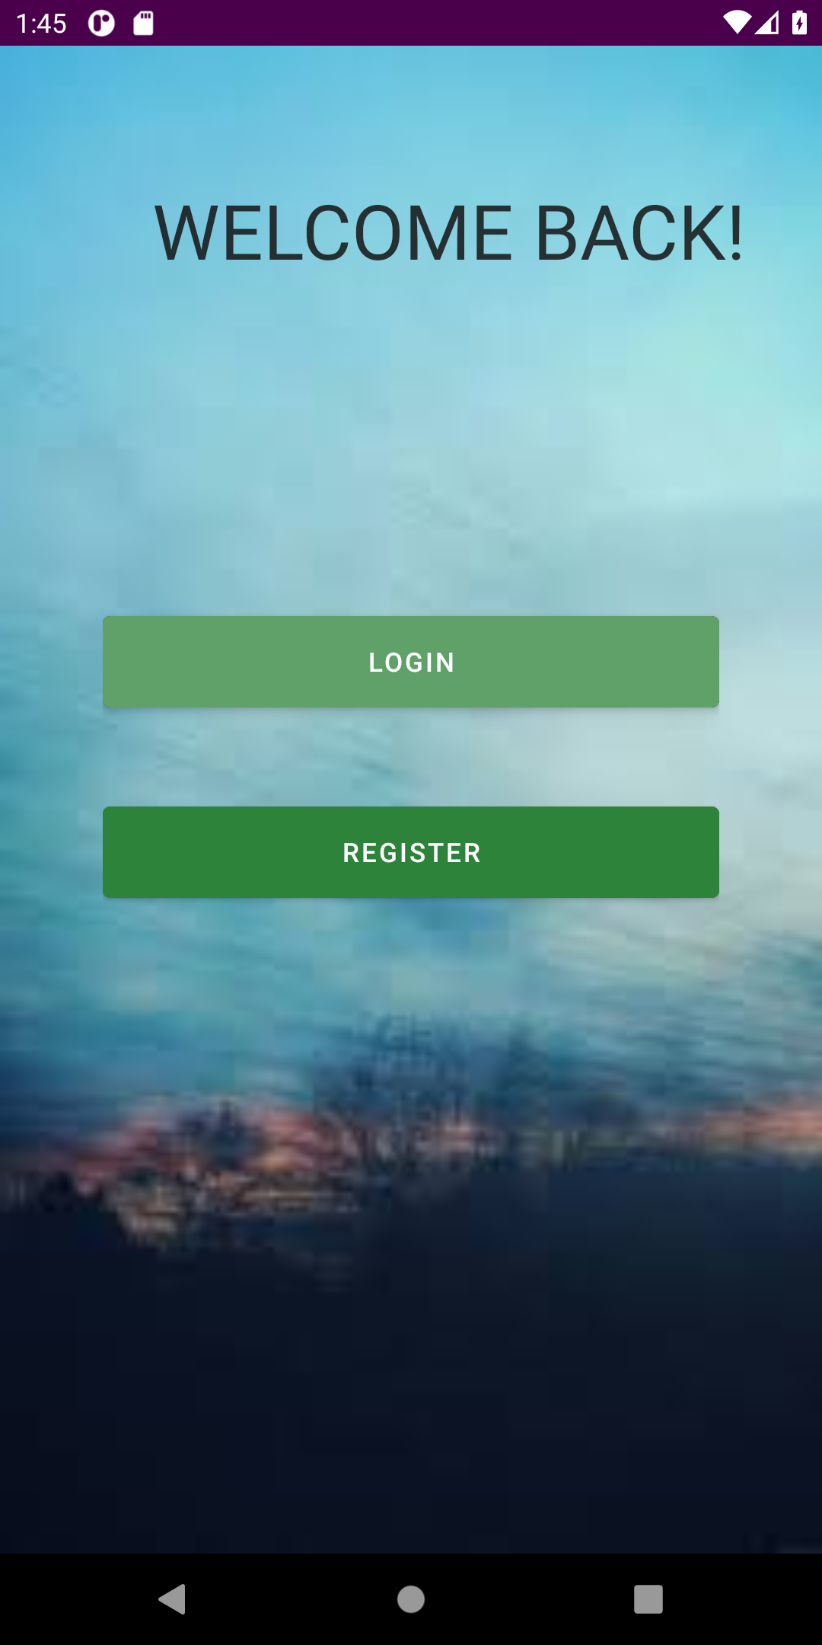

Mainactivity2.java:

|  |
| --- |
| package com.example.sqlitedemo;    import androidx.appcompat.app.AppCompatActivity;    import android.content.Intent; import android.os.Bundle; |
| import android.view.View;    public class MainActivity2 extends AppCompatActivity {    @Override  protected void onCreate(Bundle savedInstanceState) { super.onCreate(savedInstanceState); setContentView(R.layout.*activity_main2*);  }  public void goToLogin(View view) {  Intent i = new Intent(MainActivity2.this, MainActivity3.class); startActivity(i);  }  public void goToRegister(View view) {  Intent i = new Intent(MainActivity2.this, MainActivity4.class); startActivity(i);  }  } |

**activity_main2.xml:**

|  |
| --- |
| <LinearLayout xmlns:android="http://schemas.android.com/apk/res/android"  xmlns:app="http://schemas.android.com/apk/res-auto"  xmlns:tools="http://schemas.android.com/tools"  android:layout_width="match_parent"  android:layout_height="match_parent"  android:background="@drawable/abc2"  android:orientation="vertical"  tools:context=".MainActivity2">   <TextView  android:layout_width="387dp"  android:layout_height="wrap_content"  android:layout_marginLeft="40sp"  android:layout_marginTop="50dp"  android:padding="20sp"  android:paddingStart="40dp"  android:text="Welcome Back!"  android:textAllCaps="true"  android:textAppearance="@style/TextAppearance.AppCompat.Display3"  android:textColor="#D7131212"  android:textSize="40dp" />   <LinearLayout  android:layout_width="wrap_content"  android:layout_height="wrap_content"  android:layout_gravity="center_horizontal"  android:orientation="vertical"  android:layout_marginTop="150dp">   <Button  android:id="@+id/login"  android:layout_width="324dp"  android:layout_height="60dp"  android:layout_weight="0.5"  android:onClick="goToLogin"  android:layout_marginBottom="40dp"  android:backgroundTint="#2D8339"  android:textColor="#ffff"  android:text="Login" />   <Button  android:id="@+id/register"  android:layout_width="324dp"  android:layout_height="60dp"  android:layout_weight="0.5"  android:onClick="goToRegister"  android:backgroundTint="#2D8339"  android:textColor="#ffff"  android:text="Register" />   </LinearLayout>   </LinearLayout> |

**3.REGISTER ACTIVITY**

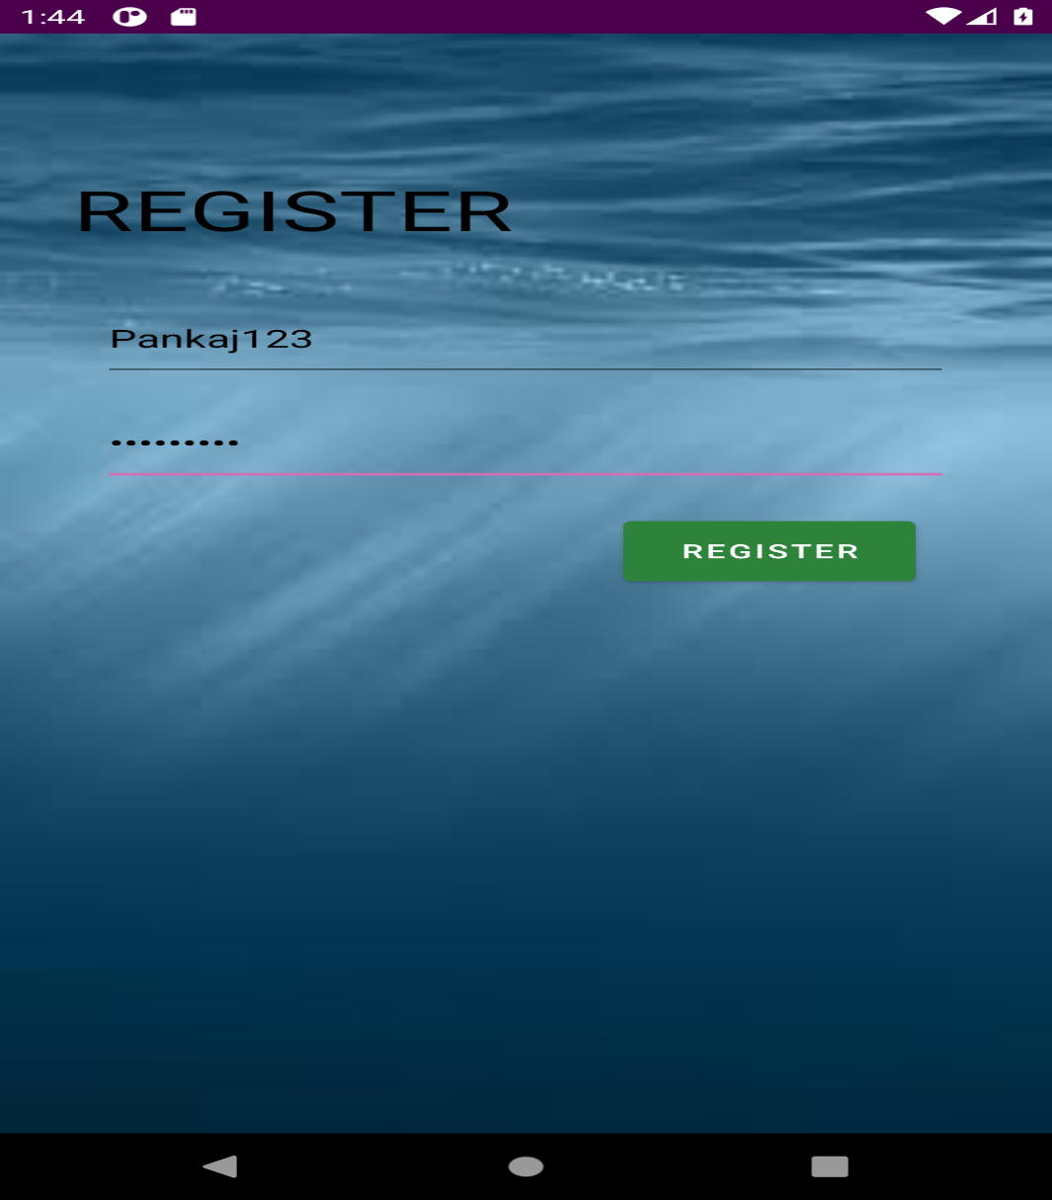

**Mainactivity4.java:**

|  |
| --- |
| package com.example.sqlitedemo;    import androidx.appcompat.app.AppCompatActivity;    import android.content.Intent; import android.os.Bundle; import android.view.View; import android.widget.Button; import android.widget.EditText; import android.widget.TextView; import android.widget.Toast;    public class MainActivity4 extends AppCompatActivity {    EditText userName,passWord;  DBHelper dbHelper;  TextView reg;    public static final String *DBNAME* = "userdb"; public static final String *TBNAME* = "users"; public static final int *DBVERSION* = 1;    @Override  protected void onCreate(Bundle savedInstanceState) { super.onCreate(savedInstanceState); setContentView(R.layout.*activity_main4*);    userName = (EditText) findViewById(R.id.*username*); passWord = (EditText) findViewById(R.id.*psw*); reg=findViewById(R.id.*reg*);    }  public void goToLogin(View view) {  dbHelper = new DBHelper(MainActivity4.this,*DBNAME*,null,*DBVERSION*); long res =  dbHelper.addUser(userName.getText().toString(),passWord.getText().toString()); if (res==-1){  Toast.*makeText*(this, "Registration Unsuccessful",  Toast.*LENGTH_LONG*).show();  }else {  Toast.*makeText*(this, "Registration Successful",  Toast.*LENGTH_LONG*).show();  Intent i = new Intent(MainActivity4.this, MainActivity3.class); startActivity(i);  }  }  } |

**activity_main4.xml :**

|  |
| --- |
| LinearLayout xmlns:android="http://schemas.android.com/apk/res/android"  xmlns:app="http://schemas.android.com/apk/res-auto"  xmlns:tools="http://schemas.android.com/tools"  android:layout_width="match_parent"  android:layout_height="match_parent"  tools:context=".MainActivity4"  android:orientation="vertical"  android:background="@drawable/abc3">  <TextView  android:id="@+id/reg"  android:layout_width="300dp"  android:layout_height="60dp"  android:text="REGISTER"  android:textColor="#000000"  android:layout_marginTop="100dp"  android:layout_marginLeft="30dp"  android:layout_marginBottom="30sp"  android:textSize="40dp"  />    <LinearLayout  android:layout_width="wrap_content"  android:layout_height="wrap_content"  android:orientation="vertical"  android:layout_gravity="center_horizontal"  >   <EditText  android:layout_width="350dp"  android:layout_height="60dp"  android:id="@+id/username"  android:hint="Username"  android:textColorHint="#1B1919"  android:textColor="#000000"  android:layout_marginLeft="30sp"  android:layout_marginRight="30sp"  android:layout_marginBottom="15dp"  android:inputType="text"  android:layout_weight="0.33" />   <EditText  android:layout_width="350dp"  android:layout_height="60dp"  android:id="@+id/psw"  android:hint="Password"  android:textColorHint="#1B1919"  android:textColor="#000000"  android:layout_marginLeft="30sp"  android:layout_marginRight="30sp"  android:layout_marginBottom="20dp"  android:inputType="textPassword"  android:layout_weight="0.33" />   <Button  android:layout_width="120dp"  android:layout_height="55sp"  android:id="@+id/register"  android:text="REGISTER"  android:layout_weight="0.33"  android:layout_marginLeft="245dp"  android:layout_marginRight="30sp"  android:backgroundTint="#2D8339"  android:onClick="goToLogin"/>    </LinearLayout>  </LinearLayout> |

**4.LOGIN ACTIVITY:**

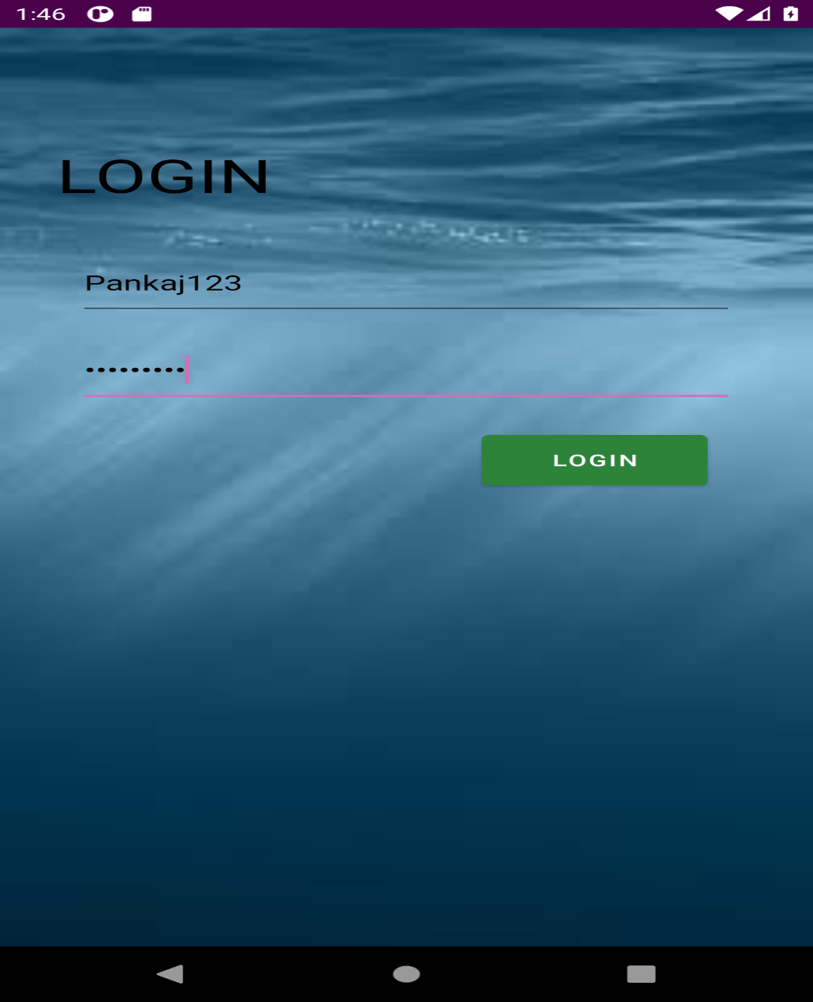

**Mainactivity3.java:**

package com.example.sqlitedemo;

|  |
| --- |
| import androidx.appcompat.app.AppCompatActivity;    import android.content.Intent; import android.os.Bundle; import android.view.View; import android.widget.Button; import android.widget.EditText; import android.widget.TextView; import android.widget.Toast;    public class MainActivity3 extends AppCompatActivity {    EditText userName,passWord;  DBHelper dbHelper;  TextView log;    public static final String *DBNAME* = "userdb"; public static final String *TBNAME* = "users"; public static final int *DBVERSION* = 1;    @Override  protected void onCreate(Bundle savedInstanceState) { super.onCreate(savedInstanceState); setContentView(R.layout.*activity_main3*);    userName = (EditText) findViewById(R.id.*username*); passWord = (EditText) findViewById(R.id.*psw*);    log=findViewById(R.id.*log*);    }  public void goToFeatures(View view) {  dbHelper = new DBHelper(MainActivity3.this,*DBNAME*,null,*DBVERSION*); int res =  dbHelper.checkUser(userName.getText().toString(),passWord.getText().toString()); if (res==1){  Toast.*makeText*(this, "Login Successful", Toast.*LENGTH_LONG*).show(); Intent i = new Intent(MainActivity3.this,MainActivity5.class); startActivity(i);  }else{  Toast.*makeText*(this, "Login Unsuccessful", Toast.*LENGTH_LONG*).show(); Intent i = new Intent(MainActivity3.this,MainActivity2.class); startActivity(i);  }  }  } |

**activity_main3.xml:**

<LinearLayout xmlns:android="http://schemas.android.com/apk/res/android"  
 xmlns:app="http://schemas.android.com/apk/res-auto"  
 xmlns:tools="http://schemas.android.com/tools"  
 android:layout_width="match_parent"  
 android:layout_height="match_parent"  
 tools:context=".MainActivity3"  
 android:orientation="vertical"  
 android:background="@drawable/abc3" >  
  
 <TextView  
 android:id="@+id/log"  
 android:layout_width="300dp"  
 android:layout_height="60dp"  
 android:text="LOGIN"  
 android:textColor="#000000"  
 android:layout_marginTop="100dp"  
 android:layout_marginLeft="30dp"  
 android:layout_marginBottom="30sp"  
 android:textSize="40dp"  
 />  
  
 <LinearLayout  
 android:layout_width="wrap_content"  
 android:layout_height="wrap_content"  
 android:orientation="vertical"  
 android:layout_gravity="center_horizontal"  
 >  
  
  
  
 <EditText  
 android:id="@+id/username"  
 android:layout_width="350dp"  
 android:layout_height="60dp"  
 android:layout_weight="0.33"  
 android:layout_marginLeft="30sp"  
 android:layout_marginRight="30sp"  
 android:layout_marginBottom="15dp"  
 android:textColor="#000000"  
 android:hint="Username"  
 android:textColorHint="#2B2929"  
 android:inputType="text" />  
  
 <EditText  
 android:layout_width="350dp"  
 android:layout_height="60dp"  
 android:id="@+id/psw"  
 android:hint="Password"  
 android:textColor="#000000"  
 android:layout_marginLeft="30sp"  
 android:layout_marginRight="30sp"  
 android:layout_marginBottom="20dp"  
 android:inputType="textPassword"  
 android:textColorHint="#2B2929"  
 android:layout_weight="0.33"  
 style=""/>  
  
 <Button  
 android:id="@+id/login"  
 android:layout_width="120dp"  
 android:layout_height="55sp"  
 android:textColor="#ffff"  
 android:layout_marginLeft="245dp"  
 android:layout_marginRight="30sp"  
 android:layout_weight="0.33"  
 android:onClick="goToFeatures"  
 android:backgroundTint="#2D8339"  
 android:text="LOGIN" />  
  
 </LinearLayout>  
  
</LinearLayout>

**5.ON SUCCESSFUL LOGIN-ADMIN ACTIVITY:**

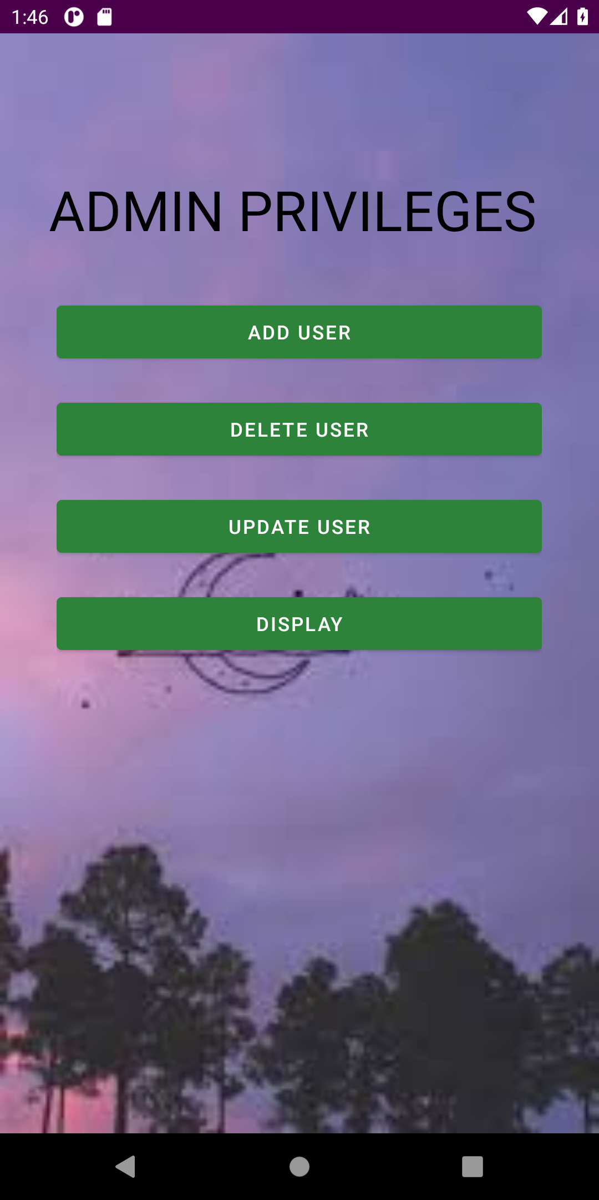

**Mainactivity5.java:**

|  |
| --- |
| package com.example.sqlitedemo;    import androidx.appcompat.app.AppCompatActivity;    import android.content.Intent; import android.os.Bundle; import android.view.View; import android.widget.TextView;    public class MainActivity5 extends AppCompatActivity {    TextView adm;    @Override  protected void onCreate(Bundle savedInstanceState) { super.onCreate(savedInstanceState); setContentView(R.layout.*activity_main5*); adm=findViewById(R.id.*adm*);  }  public void userAdd(View view) {  Intent i = new Intent(MainActivity5.this,MainActivity6.class); startActivity(i);  }  public void userDelete(View view) {  Intent i = new Intent(MainActivity5.this,MainActivity7.class); startActivity(i);  }  public void userUpdate(View view) {  Intent i = new Intent(MainActivity5.this,MainActivity8.class); startActivity(i);  }  public void userDisplay(View view) {  Intent i = new Intent(MainActivity5.this,MainActivity9.class); startActivity(i);  }  } |

**activity_main5.xml:**

<LinearLayout xmlns:android="http://schemas.android.com/apk/res/android"  
 xmlns:app="http://schemas.android.com/apk/res-auto"  
 xmlns:tools="http://schemas.android.com/tools"  
 android:layout_width="match_parent"  
 android:layout_height="match_parent"  
 tools:context=".MainActivity5"  
 android:orientation="vertical"  
 android:background="@drawable/abc4">  
  
  
 <TextView  
 android:id="@+id/adm"  
 android:layout_width="wrap_content"  
 android:layout_height="60dp"  
 android:text="ADMIN PRIVILEGES"  
 android:textColor="#000000"  
 android:layout_marginTop="100dp"  
 android:layout_marginLeft="35dp"  
 android:layout_marginBottom="30sp"  
 android:textSize="40dp"  
 />  
  
 <LinearLayout  
 android:layout_width="wrap_content"  
 android:layout_height="wrap_content"  
 android:orientation="vertical"  
 android:layout_gravity="center_horizontal"  
 >  
  
 <Button  
 android:layout_width="350dp"  
 android:layout_height="50dp"  
 android:id="@+id/add"  
 android:text="ADD USER"  
 android:layout_weight="0.25"  
 android:layout_marginBottom="20dp"  
 android:backgroundTint="#2D8339"  
 android:textColor="#ffff"  
 android:onClick="userAdd"/>  
  
 <Button  
 android:layout_width="350dp"  
 android:layout_height="50dp"  
 android:id="@+id/delete"  
 android:textColor="#ffff"  
 android:text="DELETE USER"  
 android:layout_marginBottom="20dp"  
 android:layout_weight="0.25"  
 android:backgroundTint="#2D8339"  
 android:onClick="userDelete"/>  
  
 <Button  
 android:layout_width="350dp"  
 android:layout_height="50dp"  
 android:id="@+id/update"  
 android:textColor="#ffff"  
 android:layout_marginBottom="20dp"  
 android:text="UPDATE USER"  
 android:layout_weight="0.25"  
 android:backgroundTint="#2D8339"  
 android:onClick="userUpdate"/>  
  
 <Button  
 android:layout_width="350dp"  
 android:layout_height="50dp"  
 android:id="@+id/display"  
 android:textColor="#ffff"  
 android:text="DISPLAY"  
 android:layout_marginBottom="20dp"  
 android:backgroundTint="#2D8339"  
 android:layout_weight="0.25"  
 android:onClick="userDisplay"/>  
  
 </LinearLayout>  
  
</LinearLayout>

**6.ADD USER ACTIVITY:**

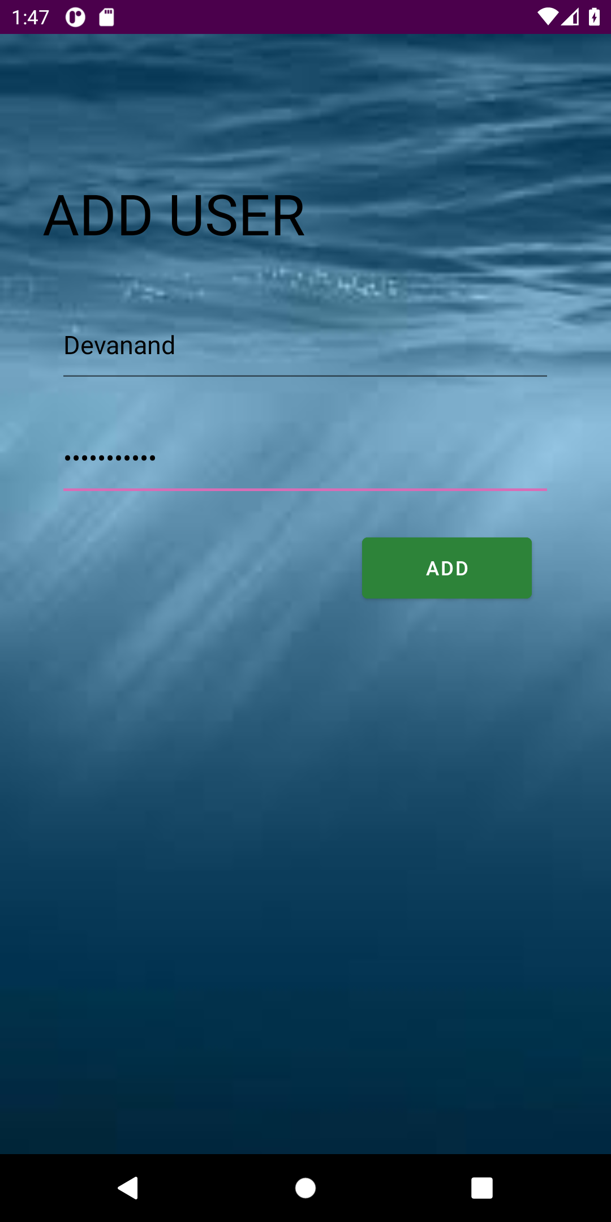

Mainactivity6.java:

package com.example.sqlitedemo;

import androidx.appcompat.app.AppCompatActivity;

import android.content.Intent;

|  |
| --- |
| import android.os.Bundle; import android.view.View; import android.widget.EditText; import android.widget.TextView; import android.widget.Toast;    public class MainActivity6 extends AppCompatActivity {    EditText userName,passWord;  DBHelper dbHelper;  TextView adu;    public static final String *DBNAME* = "userdb"; public static final String *TBNAME* = "users"; public static final int *DBVERSION* = 1;    @Override  protected void onCreate(Bundle savedInstanceState) { super.onCreate(savedInstanceState); setContentView(R.layout.*activity_main6*);    userName = (EditText) findViewById(R.id.*username*); passWord = (EditText) findViewById(R.id.*psw*); adu=findViewById(R.id.*adu*);    }  public void userAdd(View view) {  dbHelper = new DBHelper(MainActivity6.this,*DBNAME*,null,*DBVERSION*); long res =  dbHelper.addUser(userName.getText().toString(),passWord.getText().toString()); if (res == -1){  Toast.*makeText*(this, "Insert Unsuccessful", Toast.*LENGTH_LONG*).show(); }else{  Toast.*makeText*(this, "Insert Successful", Toast.*LENGTH_LONG*).show(); }  Intent i = new Intent(MainActivity6.this,MainActivity5.class); startActivity(i);  }  } |

**activity_main6.xml:**

<LinearLayout xmlns:android="http://schemas.android.com/apk/res/android"  
 xmlns:app="http://schemas.android.com/apk/res-auto"  
 xmlns:tools="http://schemas.android.com/tools"  
 android:layout_width="match_parent"  
 android:layout_height="match_parent"  
 tools:context=".MainActivity6"  
 android:orientation="vertical"  
 android:background="@drawable/abc3">  
  
 <TextView  
 android:id="@+id/adu"  
 android:layout_width="300dp"  
 android:layout_height="60dp"  
 android:text="ADD USER"  
 android:textColor="#000000"  
 android:layout_marginTop="100dp"  
 android:layout_marginLeft="30dp"  
 android:layout_marginBottom="30sp"  
 android:textSize="40dp"  
 />  
  
 <LinearLayout  
 android:layout_width="wrap_content"  
 android:layout_height="wrap_content"  
 android:orientation="vertical"  
 android:layout_gravity="center_horizontal"  
 >  
  
 <EditText  
 android:layout_width="350dp"  
 android:layout_height="60dp"  
 android:id="@+id/username"  
 android:hint="Username"  
 android:textColorHint="#2B2929"  
 android:textColor="#000000"  
 android:layout_marginLeft="30sp"  
 android:layout_marginRight="30sp"  
 android:layout_marginBottom="20dp"  
 android:inputType="text"  
 android:layout_weight="0.33" />  
  
 <EditText  
 android:layout_width="350dp"  
 android:layout_height="60dp"  
 android:id="@+id/psw"  
 android:hint="Password"  
 android:textColorHint="#2B2929"  
 android:textColor="#000000"  
 android:layout_marginLeft="30sp"  
 android:layout_marginRight="30sp"  
 android:layout_marginBottom="20dp"  
 android:inputType="textPassword"  
 android:layout_weight="0.33" />  
  
 <Button  
 android:id="@+id/add"  
 android:layout_width="120dp"  
 android:layout_height="55sp"  
 android:layout_marginLeft="245dp"  
 android:layout_marginRight="30sp"  
 android:backgroundTint="#2D8339"  
 android:layout_weight="0.33"  
 android:onClick="userAdd"  
 android:text="ADD" />  
  
 </LinearLayout>

**7.DELETE USER ACTIVITY:**

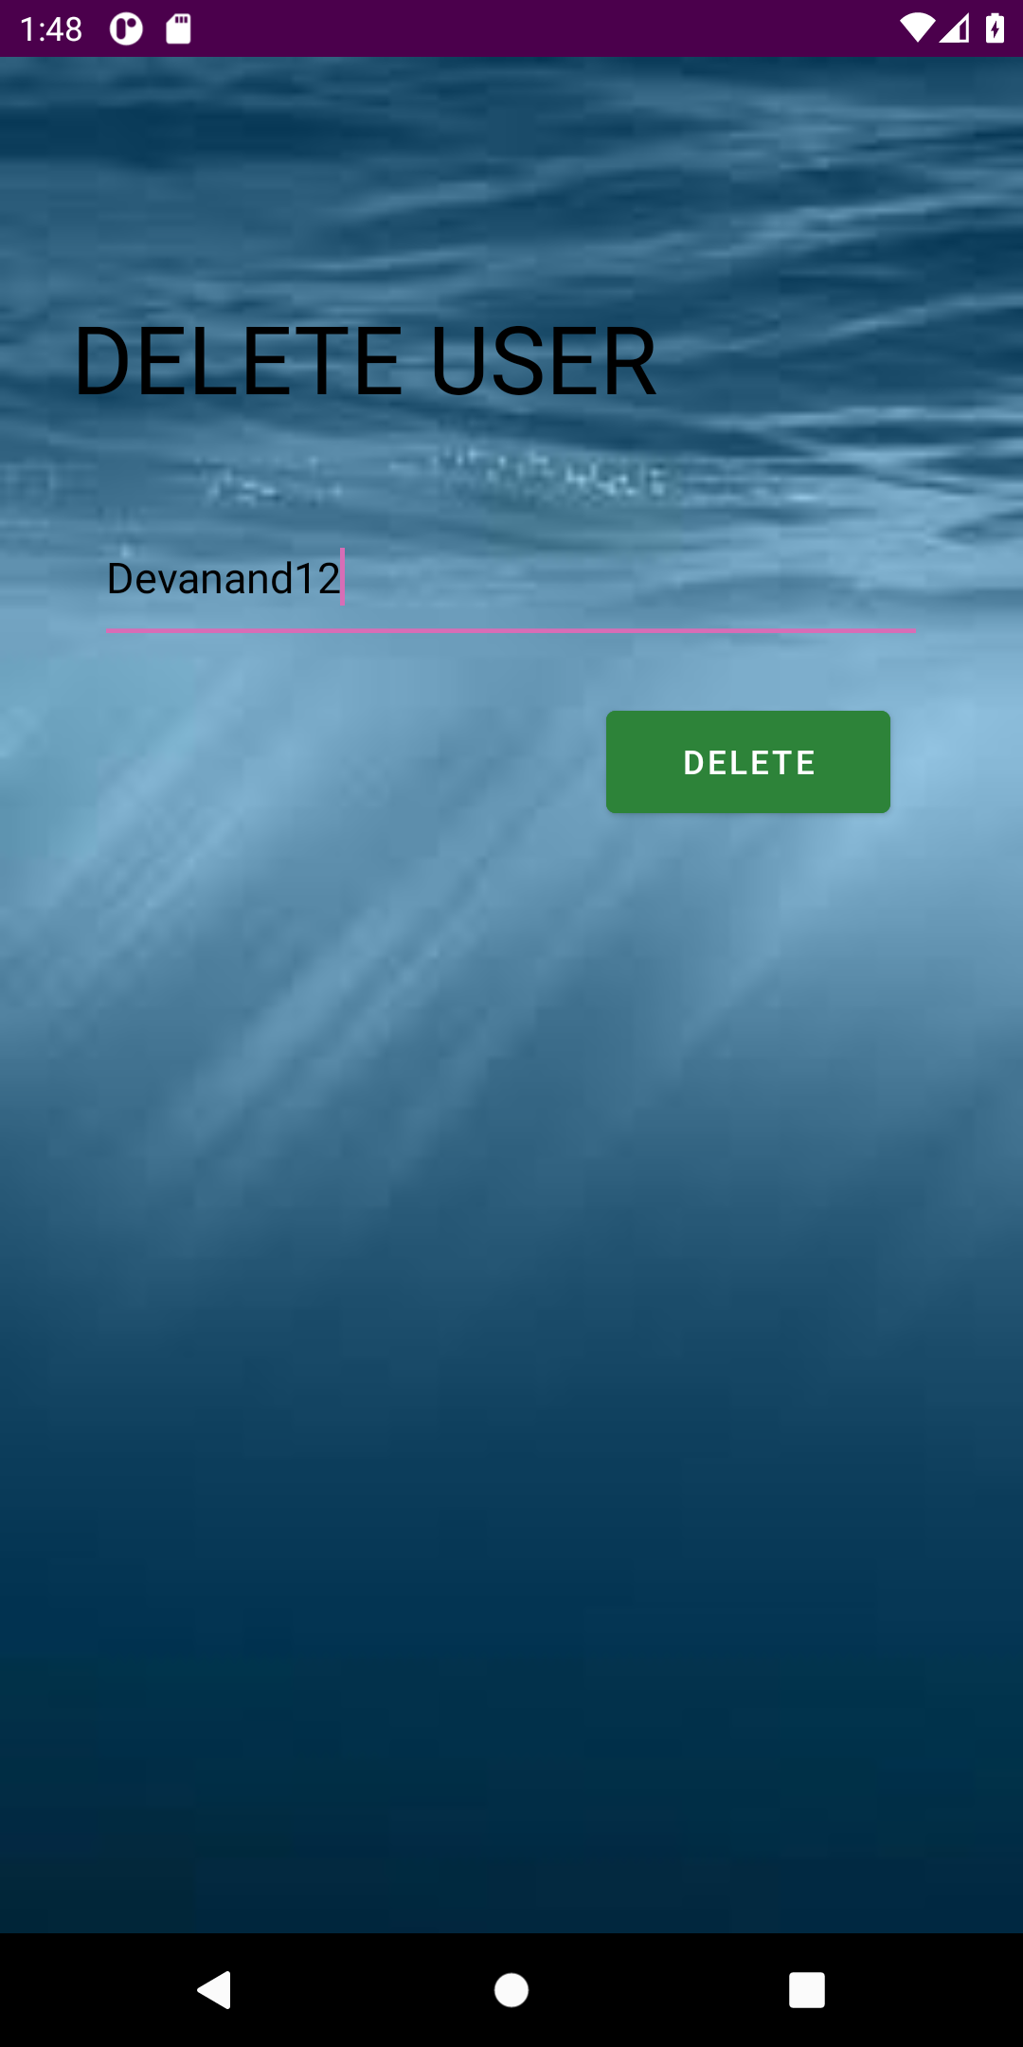

**Mainactivity7.java:**

package com.example.sqlitedemo;

|  |
| --- |
| import androidx.appcompat.app.AppCompatActivity;    import android.content.Intent; import android.os.Bundle; import android.view.View; import android.widget.EditText; import android.widget.TextView; import android.widget.Toast;    public class MainActivity7 extends AppCompatActivity {    EditText userName;  DBHelper dbHelper;  TextView del;    public static final String *DBNAME* = "userdb"; public static final String *TBNAME* = "users"; public static final int *DBVERSION* = 1;      @Override  protected void onCreate(Bundle savedInstanceState) { super.onCreate(savedInstanceState); setContentView(R.layout.*activity_main7*);    userName = (EditText) findViewById(R.id.*username*); del=findViewById(R.id.*del*);    }  public void userDelete(View view) {  dbHelper = new DBHelper(MainActivity7.this,*DBNAME*,null,*DBVERSION*); dbHelper.deleteUser(userName.getText().toString());  Toast.*makeText*(this, "Deletion Successful", Toast.*LENGTH_LONG*).show();  Intent i = new Intent(MainActivity7.this,MainActivity5.class); startActivity(i);  }  } |

**activity_main7.xml:**

LinearLayout xmlns:android="http://schemas.android.com/apk/res/android"  
 xmlns:app="http://schemas.android.com/apk/res-auto"  
 xmlns:tools="http://schemas.android.com/tools"  
 android:layout_width="match_parent"  
 android:layout_height="match_parent"  
 tools:context=".MainActivity7"  
 android:orientation="vertical"  
 android:background="@drawable/abc3">  
  
 <TextView  
 android:id="@+id/del"  
 android:layout_width="300dp"  
 android:layout_height="60dp"  
 android:text="DELETE USER"  
 android:textColor="#000000"  
 android:layout_marginTop="100dp"  
 android:layout_marginLeft="30dp"  
 android:layout_marginBottom="30sp"  
 android:textSize="40dp"  
 />  
  
 <LinearLayout  
 android:layout_width="wrap_content"  
 android:layout_height="wrap_content"  
 android:orientation="vertical"  
 android:layout_gravity="center_horizontal"  
 >  
  
 <EditText  
 android:layout_width="350dp"  
 android:layout_height="60dp"  
 android:id="@+id/username"  
 android:hint="Username"  
 android:textColorHint="#2B2929"  
 android:textColor="#000000"  
 android:layout_marginLeft="30sp"  
 android:layout_marginRight="30sp"  
 android:layout_marginBottom="20dp"  
 android:inputType="text"  
 android:layout_weight="0.5" />  
  
 <Button  
 android:id="@+id/delete"  
 android:layout_width="120dp"  
 android:layout_height="55dp"  
 android:layout_marginStart="245dp"  
 android:layout_weight="0.5"  
 android:onClick="userDelete"  
 android:layout_marginLeft="245dp"  
 android:layout_marginRight="30sp"  
 android:backgroundTint="#2D8339"  
 android:shadowColor="#A89B9B"  
 android:text="DELETE" />  
  
 </LinearLayout>  
  
</LinearLayout>

**8.UPDATE USER ACTIVITY:**

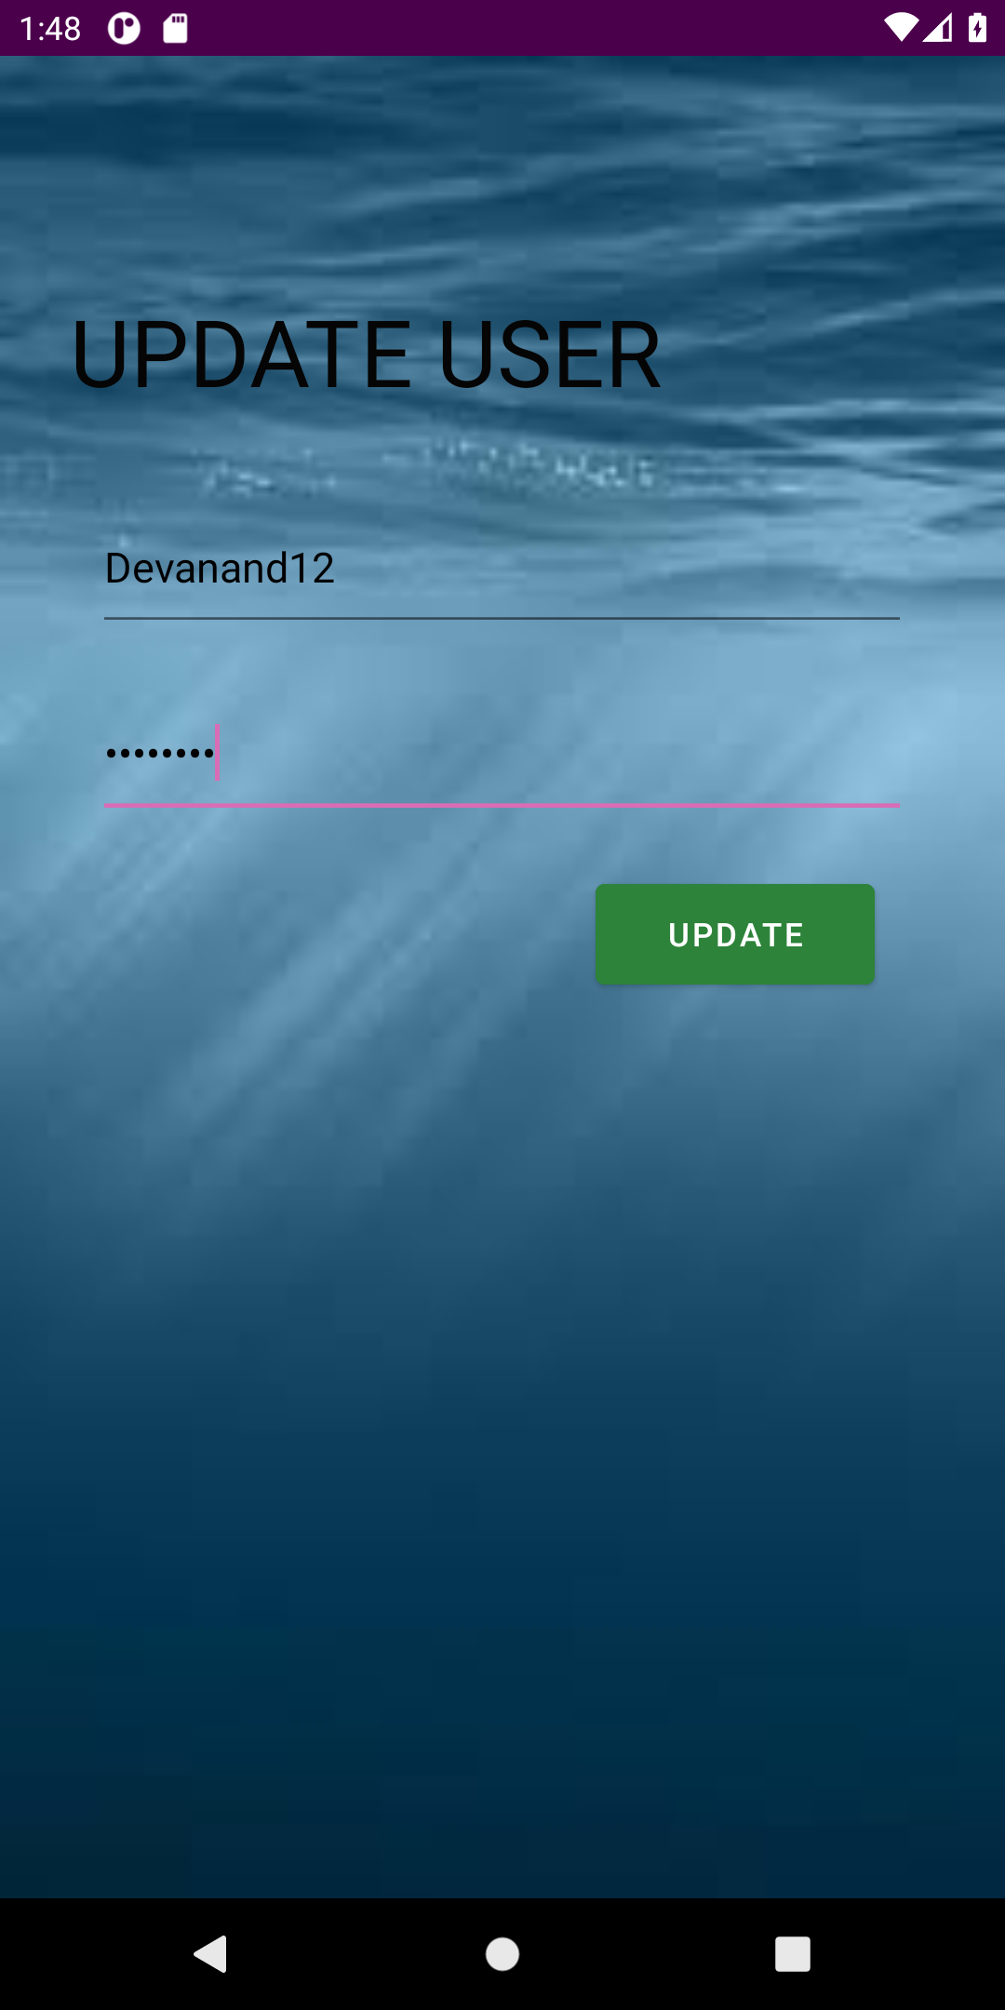

**Mainactivity8.java:**

|  |
| --- |
| package com.example.sqlitedemo;    import androidx.appcompat.app.AppCompatActivity;    import android.content.Intent; import android.os.Bundle; import android.view.View; import android.widget.EditText; import android.widget.TextView; |
| import android.widget.Toast;    public class MainActivity8 extends AppCompatActivity {    EditText userName,passWord;  DBHelper dbHelper;  TextView upd;    public static final String *DBNAME* = "userdb"; public static final String *TBNAME* = "users"; public static final int *DBVERSION* = 1;    @Override  protected void onCreate(Bundle savedInstanceState) { super.onCreate(savedInstanceState); setContentView(R.layout.*activity_main8*);    userName = (EditText) findViewById(R.id.*username*); passWord = (EditText) findViewById(R.id.*psw*); upd=findViewById(R.id.*upd*);    }  public void userUpdate(View view) {  dbHelper = new DBHelper(MainActivity8.this,*DBNAME*,null,*DBVERSION*);    dbHelper.updateUser(userName.getText().toString(),passWord.getText().toString());  Toast.*makeText*(this, "Updation Successful", Toast.*LENGTH_LONG*).show();  Intent i = new Intent(MainActivity8.this,MainActivity5.class); startActivity(i);  }  } |

**activity_main8.xml:**

<LinearLayout xmlns:android="http://schemas.android.com/apk/res/android"  
 xmlns:app="http://schemas.android.com/apk/res-auto"  
 xmlns:tools="http://schemas.android.com/tools"  
 android:layout_width="match_parent"  
 android:layout_height="match_parent"  
 tools:context=".MainActivity8"  
 android:orientation="vertical"  
 android:background="@drawable/abc3">  
  
 <TextView  
 android:id="@+id/upd"  
 android:layout_width="300dp"  
 android:layout_height="60dp"  
 android:text="UPDATE USER"  
 android:textColor="#050505"  
 android:layout_marginTop="100dp"  
 android:layout_marginLeft="30dp"  
 android:layout_marginBottom="30sp"  
 android:textSize="40dp"  
 />  
  
 <LinearLayout  
 android:layout_width="wrap_content"  
 android:layout_height="wrap_content"  
 android:orientation="vertical"  
 android:layout_gravity="center_horizontal"  
 >  
  
 <EditText  
 android:layout_width="350dp"  
 android:layout_height="60dp"  
 android:id="@+id/username"  
 android:hint="Username"  
 android:textColorHint="#2B2929"  
 android:textColor="#000000"  
 android:layout_marginLeft="30sp"  
 android:layout_marginRight="30sp"  
 android:layout_marginBottom="20dp"  
 android:inputType="text"  
 android:layout_weight="0.33" />  
  
 <EditText  
 android:layout_width="350dp"  
 android:layout_height="60dp"  
 android:id="@+id/psw"  
 android:hint="Password"  
 android:textColorHint="#2B2929"  
 android:textColor="#000000"  
 android:layout_marginLeft="30sp"  
 android:layout_marginRight="30sp"  
 android:layout_marginBottom="20dp"  
 android:inputType="textPassword"  
 android:layout_weight="0.33" />  
  
 <Button  
 android:id="@+id/update"  
 android:layout_width="120dp"  
 android:layout_height="55sp"  
 android:layout_marginLeft="245dp"  
 android:layout_marginRight="30sp"  
 android:backgroundTint="#2D8339"  
 android:layout_weight="0.33"  
 android:onClick="userUpdate"  
 android:shadowColor="#A89B9B"  
 android:text="UPDATE" />  
  
 </LinearLayout>  
  
</LinearLayout>

**9.DISPLAY USERS ACTIVITY:** 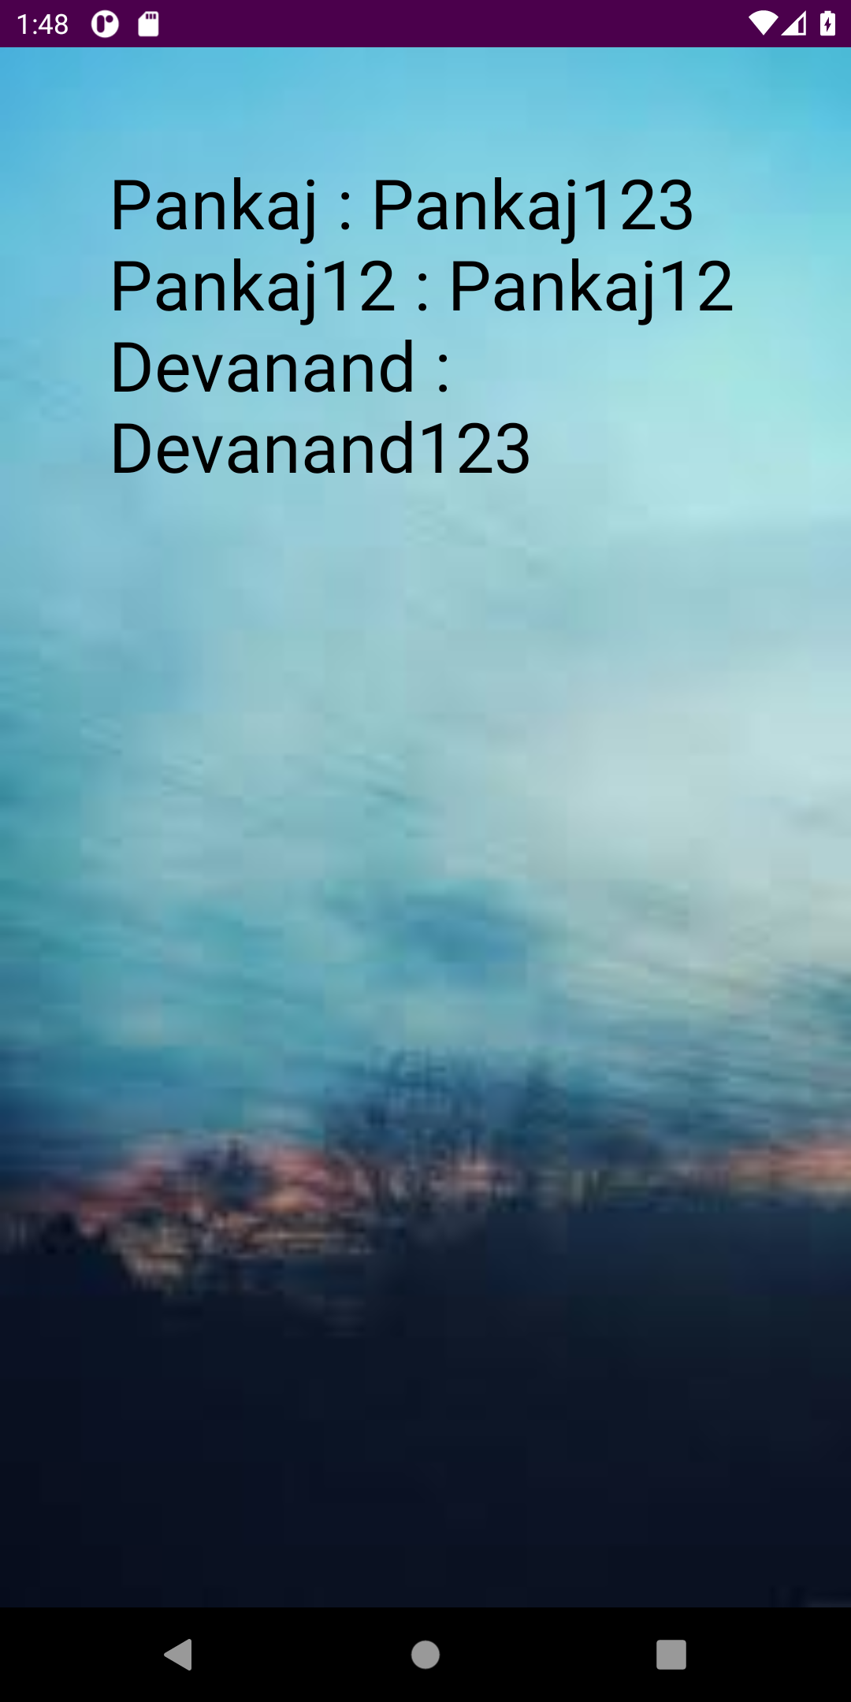

Mainactivity9.java:

|  |
| --- |
| package com.example.sqlitedemo;    import androidx.appcompat.app.AppCompatActivity;    import android.os.Bundle; import android.widget.TextView;    public class MainActivity9 extends AppCompatActivity { |
| TextView contents;  DBHelper dbHelper;    @Override  protected void onCreate(Bundle savedInstanceState) { super.onCreate(savedInstanceState); setContentView(R.layout.*activity_main9*);    contents = (TextView) findViewById(R.id.*content*); dbHelper = new  DBHelper(MainActivity9.this,DBHelper.*DBNAME*,null,DBHelper.*DBVERSION*);  String data = dbHelper.displayUsers(); contents.setText(data);    }  } |

**activity_main9.xml:**

<LinearLayout xmlns:android="http://schemas.android.com/apk/res/android"  
 xmlns:app="http://schemas.android.com/apk/res-auto"  
 xmlns:tools="http://schemas.android.com/tools"  
 android:layout_width="match_parent"  
 android:layout_height="match_parent"  
 tools:context=".MainActivity9"  
 android:orientation="vertical"  
 android:background="@drawable/abc2">  
  
 <TextView  
 android:layout_width="wrap_content"  
 android:layout_height="wrap_content"  
 android:id="@+id/content"  
 android:text="Users:"  
 android:padding="25sp"  
 android:textColor="#000000"  
 android:textSize="35sp"  
 android:layout_margin="30dp"/>

|  |
| --- |
|  |

**DBHelper.java:**

|  |
| --- |
| // Model  package com.example.sqlitedemo;    import android.content.ContentValues; import android.content.Context; import android.database.Cursor;  import android.database.sqlite.SQLiteDatabase; import android.database.sqlite.SQLiteOpenHelper;  import android.widget.Toast;    import androidx.annotation.Nullable;    public class DBHelper extends SQLiteOpenHelper { |

|  |
| --- |
| // To-do:  // 1. Class extends SQLiteOpenHelper  // 2. Implement the override functions of SQLiteOpenHelper  // 3. Override the constructor    public static final String *DBNAME* = "userdb"; public static final String *TBNAME* = "users"; public static final int *DBVERSION* = 1;    public String place_username = "username"; public String place_password = "password";    public DBHelper(@Nullable Context context, @Nullable String name, @Nullable  SQLiteDatabase.CursorFactory factory, int version) { super(context, *DBNAME*, null, *DBVERSION*);  }    @Override  public void onCreate(SQLiteDatabase db) {  db.execSQL("CREATE TABLE " +*TBNAME*+ "(username VARCHAR, password VARCHAR"  + ");" );  }    @Override  public void onUpgrade(SQLiteDatabase db, int oldVersion, int newVersion) { db.execSQL("DROP TABLE IF EXISTS " +*TBNAME*); onCreate(db);  }  public long addUser(String uname, String psw){ SQLiteDatabase db = this.getWritableDatabase();  ContentValues cv = new ContentValues(); cv.put("username", uname); cv.put("password", psw);  long res = db.insert(*TBNAME*,null,cv); db.close(); return res;  }  public void deleteUser(String uname){  SQLiteDatabase db = this.getWritableDatabase();  db.execSQL("DELETE FROM " +*TBNAME*+ " WHERE username='" +uname+ "';"); db.close();  }  public void updateUser(String uname,String newpsw){ SQLiteDatabase db = this.getWritableDatabase();  db.execSQL("UPDATE " +*TBNAME*+ " SET password='" +newpsw+ "' WHERE username='" +uname+ "';"); db.close();  }    // public String display(){  // SQLiteDatabase db = this.getReadableDatabase();  // Cursor cr = db.rawQuery("SELECT * FROM " +TBNAME+ ";", null);  // String res = "";  // if (cr.moveToFirst()){ |

|  |
| --- |
| // while (cr.moveToNext()){  // res = cr.getString(0) +":" + cr.getString(1);  // }  // }  // return res;  // }  public int checkUser(String uname,String psw){ SQLiteDatabase db = this.getReadableDatabase();  Cursor cr = db.query(*TBNAME*,new  String[]{place_username,place_password},"username=? AND password=?",new  String[]{uname,psw},null,null,null); if(cr.moveToFirst()){ db.close(); cr.close(); return 1; }else{ db.close(); cr.close(); return -1;  }  }  public String displayUsers(){  SQLiteDatabase db = this.getReadableDatabase();  Cursor cr = db.rawQuery("SELECT * FROM " +*TBNAME*+ ";",null);  StringBuilder data = new StringBuilder();  if (cr.moveToFirst()){ do { data.append(cr.getString(0)).append(" :  ").append(cr.getString(1)).append("\n");  }while (cr.moveToNext());  }  return data.toString();  }    // private static final String DBName = "studentdb";  // private static final String TBName = "student";  // private static final int DBVERSION = 1;  //  // String place_name = "name";  // String place_usn = "usn";  //  // public DBHelper(@Nullable Context context, @Nullable String name, @Nullable  SQLiteDatabase.CursorFactory factory, int version) {  // super(context, name, factory, version);  // }  //  // @Override  // public void onCreate(SQLiteDatabase db) {  //// Create table in this function  // String createSQL = "CREATE TABLE "+TBName+"("+place_name+" VARCHAR(20),  "+place_usn+" INTEGER PRIMARY KEY);";  // db.execSQL(createSQL);  // }  //  // @Override  // public void onUpgrade(SQLiteDatabase db, int oldVersion, int newVersion) { // db.execSQL("DROP TABLE IF EXISTS "+TBName); |

// onCreate(db);

// }

//

// public void insertStudent(Student student){

// SQLiteDatabase db = this.getWritableDatabase();

// ContentValues cv = new ContentValues();

// cv.put(place_name,student.getName());

// cv.put(place_usn,student.getUsn());

// db.insert(TBName,null,cv);

// db.close();

// }

//

// public void deleteStudent(Student student){

// SQLiteDatabase db = this.getWritableDatabase();

// db.delete(TBName,place_usn + "=?",new

String[]{String.valueOf(student.getUsn())});

// db.close();

// }

//

// public int updateStudent(Student student){

// SQLiteDatabase db = this.getWritableDatabase();

// ContentValues cv = new ContentValues();

// cv.put(place_name, student.getName());

// cv.put(place_usn,student.getUsn());

// return db.update(TBName,cv,place_usn+"=?", new

String[]{String.valueOf(student.getUsn())});

// }

}

**Student.java:**

|  |
| --- |
| package com.example.sqlitedemo;    public class Student { String name; int usn;    public Student() {  }  public Student(String name, int usn) { this.name = name; this.usn = usn;  }  public String getName() {  return name;  }  public void setName(String name) { this.name = name;  }  public int getUsn() { return usn; |
| }  public void setUsn(int usn) {  this.usn = usn;  }  } |